Devin Fromond
Lab Report
ECE 2031 L04
23 September 2025

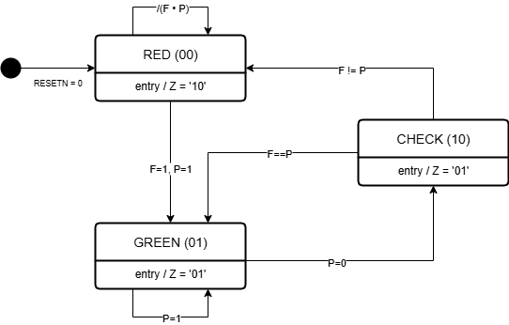
Figure 1. UML state diagram for a production line monitoring system, with the MSB (left bit) denoting RED (out of sync) output and LSB denoting GREEN (all-clear) output.

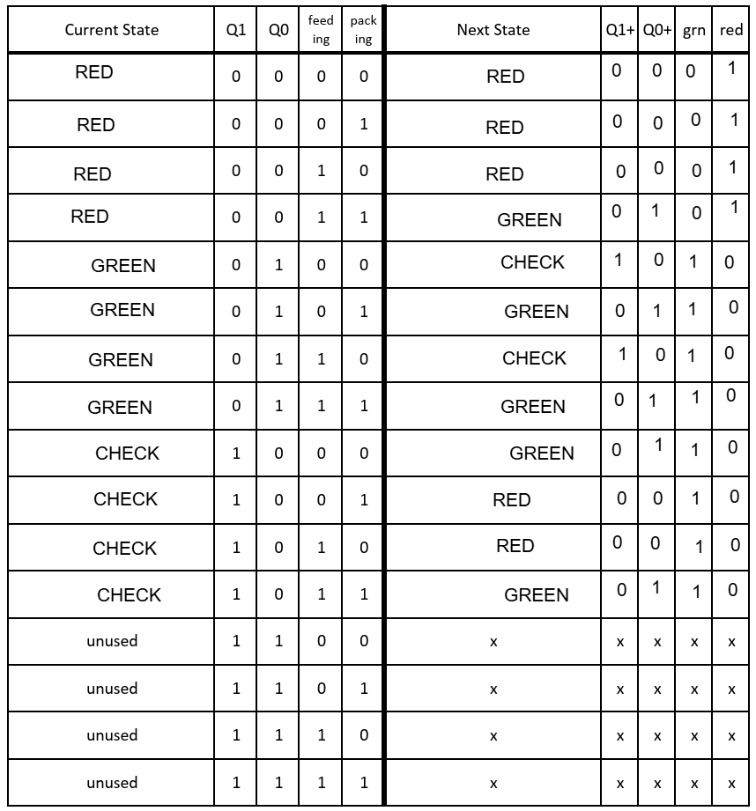
Figure 2. Transition table for the UML state diagram as in Figure 1.

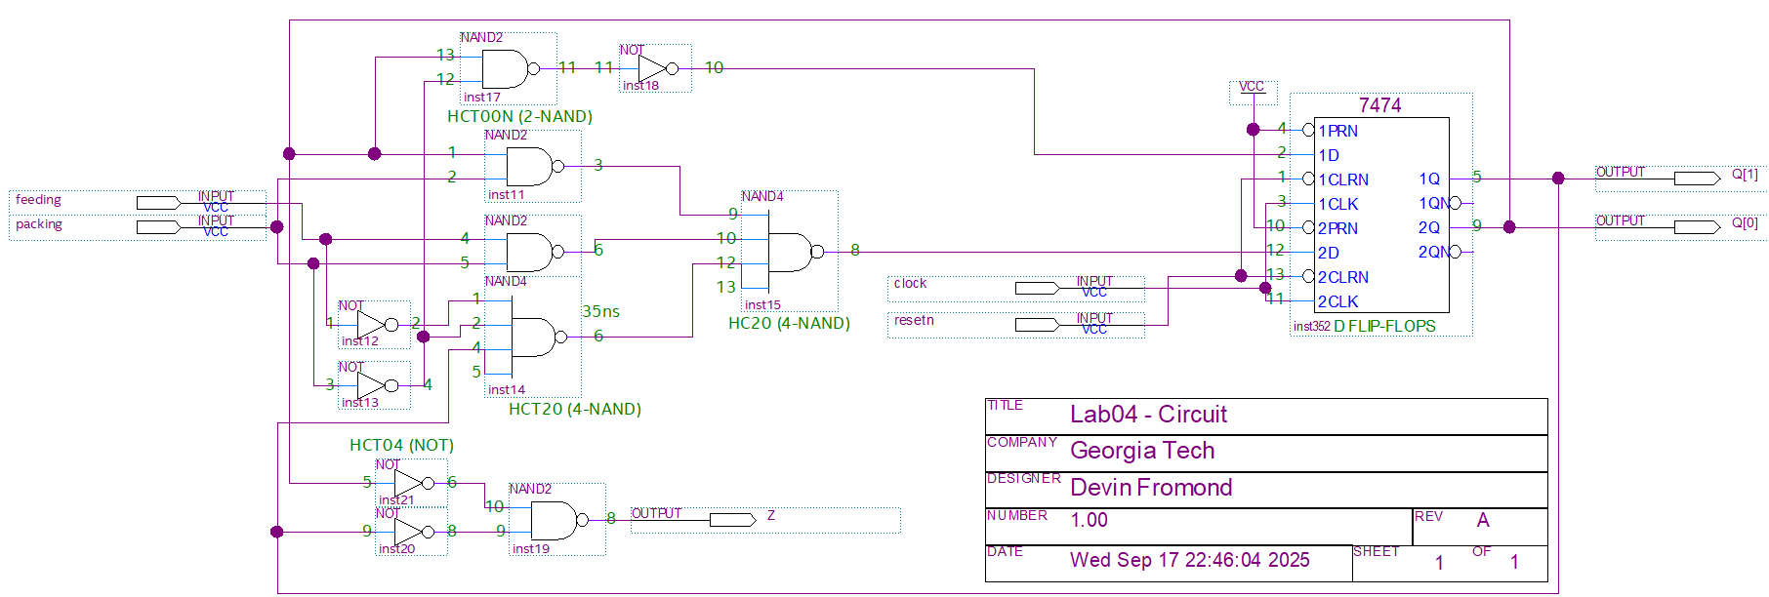
Figure 3. Schematic representing the state diagram as in Figure 1 with a 74HCT74 chip to hold sequential state logic.

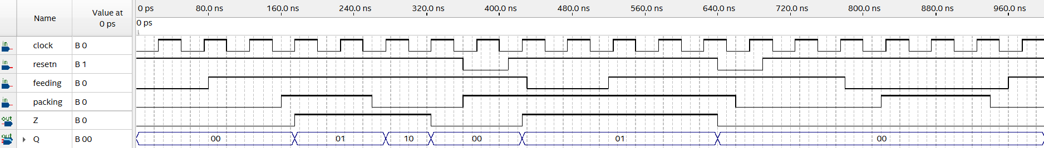
Figure 4. Simulation of the schematic as in Figure 3, highlighting the output (Z) and the state(s) (<Q1, Q0>).
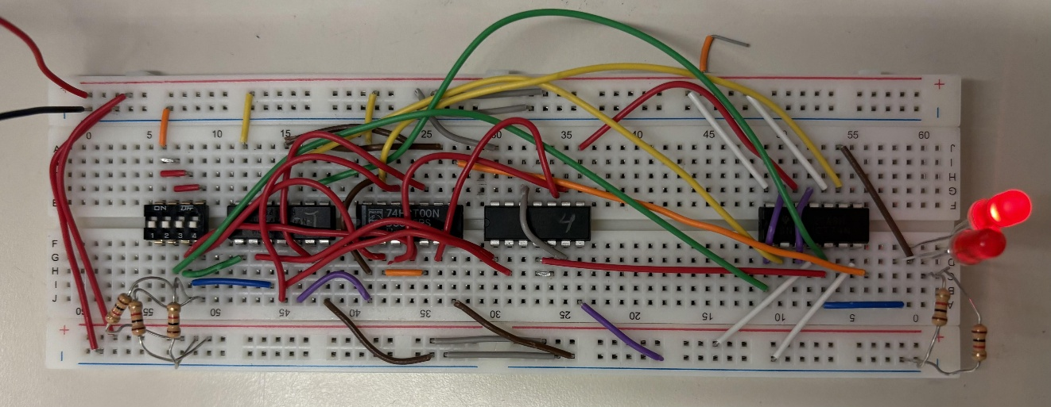
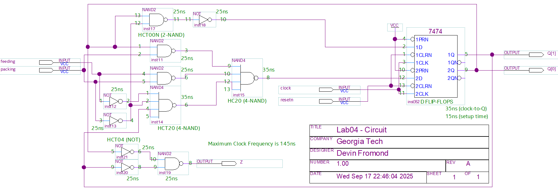
Figure 5. Breadboard prototype of Figure 3 schematic, with states shown via LEDs (top = MSB, bottom = LSB). Output omitted per lab instructions.
Figure 6. Schematic as in Figure 3 with worst-case propagation delays and maximum clock frequency calculated.

